

Project Report on

**XY- Pen Plotter**

***In partial fulfilment of the requirements for the degree of***

**Master of Engineering in**

**Mechatronics and Robotics**

Under the subject of:

**Workshop Mechatronics**

Submitted By:

|  |  |
| --- | --- |
| Rajat Joshi | 315511 |
| Sagar Patil | 315501 |
| Prabhat Gaikwad | 315007 |
| Vinit Devchandani | 315516 |
| Hikmaddin Abishov | 316029 |

Department of Mechanical Engineering

Schmalkalden University of Applied Sciences

Blechhammer 9, 98574 Schmalkalden

July 2023

**CERTIFICATE**

This is to certify that the project titled “**2D Pen plotter**” submitted by **RAJAT JOSHI: 315511** **SAGAR PATIL: 315501** **PRABHAT GAIKWAD: 315007** **VINIT DEVCHANDANI: 315516; HIKMADDIN ABISHOV: 316029;** to the Mechanical Engineering Department of Schmalkalden University of Applied Sciences, in partial fulfillment of the requirements for the award of the degree of Master of Engineering in Mechatronics and Robotics is a record of our own work.

To the best of my knowledge, this report has not been submitted to any other University or Institute for award of any degree.

|  |  |  |  |  |  |
| --- | --- | --- | --- | --- | --- |
| **Rajat**  **Joshi** | **Sagar**  **Patil** | **Prabhat**  **Gaikwad** | **Vinit Devchandani** | **Hikmaddin Abishov** |  |
| 315511 | 315501 | 315007 | 315516 | 316029 |  |

This is to certify that the statements made by the candidate are correct to the best of our knowledge and belief. It is further understood that by this certificate the undersigned do not endorse or approve any statement made, opinion expressed or conclusion drawn herein, but approve the report only for the purpose for which it is submitted

**Countersigned:**

|  |  |
| --- | --- |
| **Prof. Dr.-Ing. Stefan Roth,**  Professur Produktentwicklung / Konstruktion  Angewandte Kunststofftechnik (AKT), Fakultät Maschinenbau, Hochschule Schmalkalden,  Blechhammer 9, 98574 Schmalkalden | **Prof. Dr.-Ing. Silvio Bachmann,**  Assistant Professor & Coordinator, Fakultät Elektrotechnik, Hochschule Schmalkalden,  Blechhammer 9, 98574 Schmalkalden |

**ACKNOWLEDGEMENT**

We would like to put forth our regardful thanks to all those who had helped us in guiding us to get the most out of this golden opportunity to learn the most during this project on 2D Pen plotter.

We pay our special thanks to **Prof. Dr.-Ing. Stefan Roth, Prof. Dr.-Ing. Silvio Bachmann, Mr. Joshua Voll** & **Mr. Samuel Werner,** who provided excellent guidance as well as they had always been supporting and helpful.

We also put forth our special thanks to all the concerned persons who have enabled us to have an opportunity to work at the prestigious organization.

Thankful,

**Rajat Joshi (315511) Sagar Patil (315501) Prabhat Gaikwad (315007) Vinit Devchandani (315516) Hikmaddin Abishov(316029)**

**Table of Contents**

1. Introduction 7

1.1 Objectives 7

2. Project Goals and Project Planning 8

2.1 Project Goals and Objectives 8

2.2 Organisation Chart 8

2.3 Project Timeline 9

2.4 Development of documentation according to V-model 10

2.5 Morphological Chart: 11

3. Design Stage 12

3.1 Component Selection 12

3.2 Electrical Design 14

3.3 Mechanical CAD Design 15

3.4 Key Design Decision 17

4. Development and Fabrication Stage 20

5. Testing and Iteration 22

5.1 Testing Procedure: 22

5.2 Design Iteration: 22

6. Conclusion and Acknowledgements 27

6.1 Bill of Materials: 27

6.2 Future Scope: 30

|  |  |
| --- | --- |
| List of Figures | Pg. No. |
| Figure 1.1 Pen Plotter | 7 |
| Figure 2.1 Nikolaus Haus | 8 |
| Figure 2.2 Organisation Chart | 9 |
| Figure 2.3 V-Model | 11 |
| Figure 2.4 Morphological Chart | 12 |
| Figure 3.1 DC Motor | 13 |
| Figure 3.2 ESP32 Board | 13 |
| Figure 3.3 L298N Motor Driver | 13 |
| Figure 3.4 Pulley | 13 |
| Figure 3.5 Linear Ball Bearing | 13 |
| Figure 3.6 DC Solenoid | 13 |
| Figure 3.7 OLED Display | 13 |
| Figure 3.8 Adapter | 14 |
| Figure 3.9 GT2 Belt | 14 |
| Figure 3.10 Fastener | 14 |
| Figure 3.11 Limit Switch | 14 |
| Figure 3.12 MOSFET Switch | 14 |
| Figure 3.13 Hall Sensor | 14 |
| Figure 3.14 DC-DC Voltage Converter | 14 |
| Figure 3.15 Kill Switch | 14 |
| Figure 3.16 Electric Circuit Diagram | 15 |
| Figure 3.17 CAD Design | 16 |
| Figure 3.18 Pen Holder | 17 |
| Figure 3.19 Shaft Guiding Block | 17 |
| Figure 3.20 Wheel Supporting Assembly | 17 |
| Figure 3.21 Control Interface Block | 17 |
| Figure 3.22 OLED Display | 18 |
| Figure 3.23 Magnetic Encoder Disc | 19 |
| Figure 3.24 Pen Plotter Web UI | 20 |
| Figure 4.1 3D Printer | 21 |
| Figure 4.2 Test Piece | 22 |
| Figure 4.3 Wires and Cables | 22 |

|  |  |
| --- | --- |
| List of Tables | Pg. No. |
| Table 2.1 Project Timeline | 10 |
| Table 5.1 Verification Protocol | 24 |
| Table 5.2 Verification Report | 26 |
| Table 5.3 Validation Protocol | 29 |
| Table 5.4 Validation Report | 30 |
| Table 6.1 Bill of Material | 31 |

# Introduction

## Objectives

We are pleased to present the project report of our pen plotter, a remarkable undertaking by our group. With a clear aim in mind, we set out to design and develop a pen plotter capable of creating intricate drawings, with a specific focus on the renowned Nikolaus Haus. This project report provides a detailed account of our journey, outlining the design process, implementation strategies, testing procedures, and the successful realization of our pen plotter project.

Figure 1.1 Pen Plotter

The Nikolaus Haus, with its complex architectural details and artistic significance, presented us with an exciting challenge. Our objective was only to create a pen plotter capable of accurately reproducing the Nikolaus Haus.

The design phase encompassed a meticulous exploration of hardware, software, and mechanical components. We carefully selected the appropriate motors, sensors, and control mechanisms to achieve the desired accuracy and control. Our software development involved designing and implementing complex algorithms capable of interpreting the architectural blueprints and transforming them into precise pen movements.

Testing and evaluation played a pivotal role in validating the performance of our pen plotter. We subjected the system to a series of rigorous tests, measuring its accuracy, speed, and overall capability to recreate the Nikolaus Haus. By meticulously analysing the test results and making iterative improvements, we ensured that our pen plotter delivered exceptional results, capturing the essence of the Nikolaus Haus in every stroke.

This project report provides an in-depth account of our journey, detailing the design process, implementation strategies, testing methodologies, and the final outcome of our pen plotter project. It is a testament to our passion for innovation, dedication to precision, and appreciation for the architectural marvels that inspire us. We hope that our work not only contributes to the field of pen plotting but also sparks further exploration and creativity in the world of architectural representation and artistic expression.

# Project Goals and Project Planning

## Project Goals and Objectives

The primary objective of the project is to create a pen plotter by integrating all the available components. These components will be responsible for controlling the movement of the pen and ensuring accurate plotting on paper.

The project team will design and fabricate the necessary parts, program the control system, and assemble the pen plotter. The following tasks will be performed:

* Designing and building a functional pen plotter using specific components.
* Ensuring precise and accurate plotting on paper.

Figure 2.1 Nikolaus Haus

* Developing a user interface to control the movement of the pen.
* Testing and calibrating the pen plotter for optimal performance.
* Demonstrating the functionality and output of the pen plotter through plotted designs of **Nikolaus Haus**.

## Organisation Chart

Figure 2.2 Organisation Chart

## Project Timeline

The project timeline for the pen plotter includes phases such as research and design, component acquisition, prototyping, testing, and final implementation, spanning a period of more than three months.

Table 2.1 Project Timeline

|  |  |  |  |
| --- | --- | --- | --- |
| Phase | Tasks | Days | Start Date |
| **Idea Phase** | | 7 | 17.04.23 |
|  | Market Research | 2 |  |
|  | Benchmarking models of seniors in lab | 1 |
|  | Brainstorming for new features integration | 3 |
|  | Set User Requirement | 1 |
|  | Idea phase finished, Deliverable user requirement | 0 |
| Project Planning | | 6 | 24.04.23 |
|  | Budget and Resource Planning | 1 |  |
| Set-Up Project Team | 1 |
| Technical Specification | 2 |
| Design Specification | 2 |
| Project Planning Phase Complete | 0 |
| Development Phase | | 34 | 02.05.23 |
|  | Concept Development | 2 |  |
| Electrical Design | 2 |
| Software Design | 18 |
| Mechanical / CAD Design | 12 |
| CAD Model & Electrical Circuit Diagram Fready | 0 |
| Prototyping & Fabrication | | 14 | 02.06.23 |
|  | 3D printing of test piece for fitment | 2 |  |
| Test piece printing and checking | 1 |
| 3D printing of plastic parts | 6 |
| Assembly | 2 |
| Electrical Wiring | 3 |
| Prototype Complete | 0 |
| Testing and calibration | | 17 | 16.06.23 |
|  | Programming and Troubleshooting | 6 |  |
| X and Y Axis calibration | 3 |
| Testing drawing performance and tuning PID | 4 |
| Verification Protocol & report | 2 |
| Validation Protocol & report | 2 |
| Testing and calibration complete | 0 |
| Documentation | | 5 | 10.07.23 |
|  | Project Presentation | 5 |  |
| Project Dossier | 5 |
| Bill of material | 1 |
| Documentation Complete | 0 |

## Development of documentation according to V-model

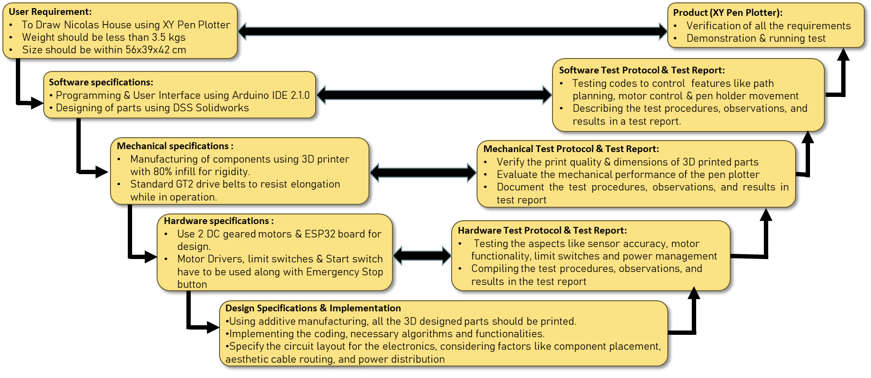

Figure 2.3 V-Model

The V-model of the pen plotter project provides a comprehensive framework for its development, ensuring a systematic and structured approach. The project begins with the User Requirement stage, where the specific needs and expectations of the users are gathered and documented. This information forms the foundation for the subsequent stages. The Technical Specification stage focuses on defining the detailed specifications of the pen plotter system, considering aspects such as size, resolution, speed, and accuracy. The Software Requirements stage identifies and documents the necessary software functionalities, user interface design, and programming requirements. The Mechanical Requirements stage specifies the mechanical components, materials, and design considerations, ensuring the robustness and functionality of the pen plotter's physical structure. The Electrical Requirements stage involves determining the electrical components, circuitry, and power requirements for the pen plotter.

The Implementation stage encompasses building the pen plotter system, including the assembly of mechanical and electrical components, integration of control systems, and software development. In the System Integration stage, the individual subsystems are combined and tested to ensure proper interaction and functionality. The Verification of Design stage involves rigorous testing and evaluation to ensure that the pen plotter design meets the specified requirements. System Testing is conducted to validate the overall performance, functionality, and reliability of the pen plotter under various conditions. The Test Report documents the results and findings from the system testing phase, including any issues encountered and their resolutions.

Finally, the completed and tested product, the XY Pen Plotter, is ready for deployment and use.

By following the V-model, the pen plotter project ensures a systematic and thorough approach to its development, resulting in a reliable and high-quality pen plotter system.

## Morphological Chart:

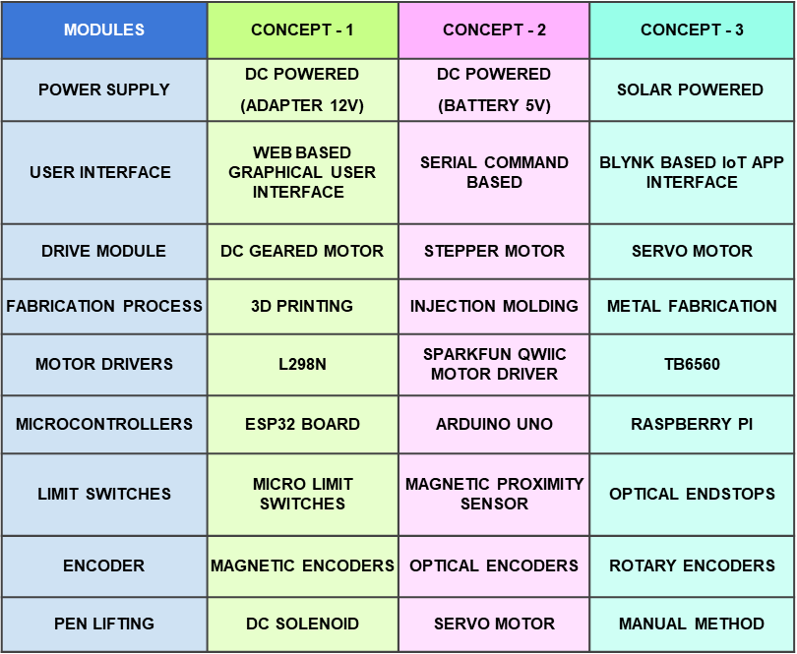

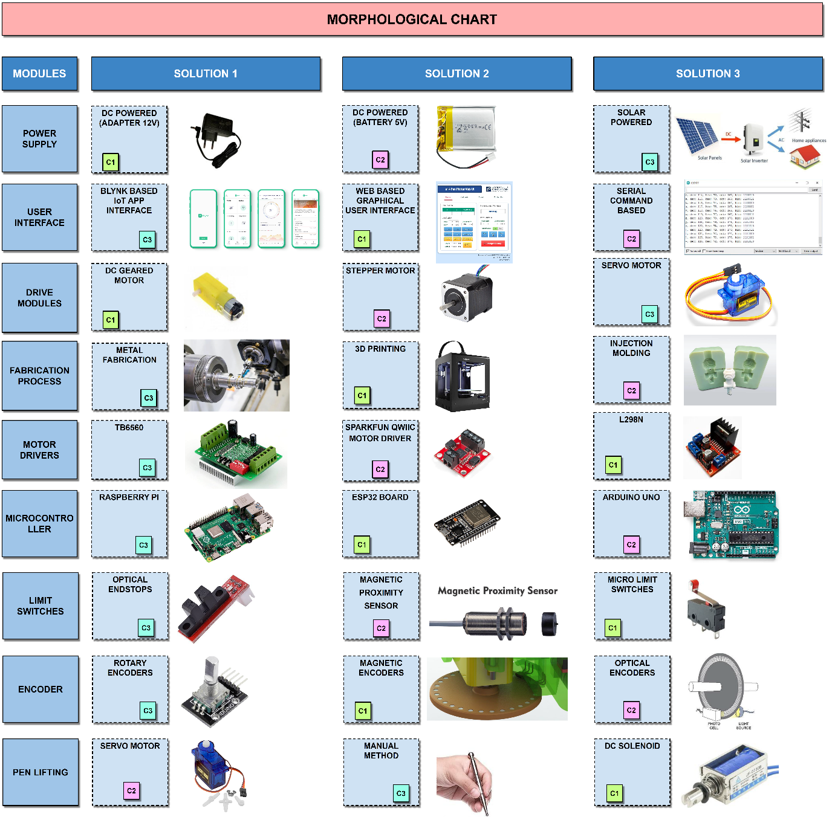

Figure 2.4 Morphological Chart

The morphological chart for the pen plotter project is a visual tool that presents various design options and their corresponding features. It helps in systematically exploring and selecting components such as motors, controllers, sensors, pens, and user interface elements, enabling informed decision-making for the pen plotter's design and functionality.

# Design Stage

## Component Selection

1. D.C. Motor: Two DC motors are used in pen plotter project precise, rotary motion for controlling pen movement, enabling accurate plotting and drawing on various surfaces.

Figure 3.1 D.C. Motor

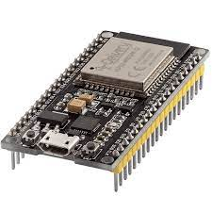

1. **ESP32 Board:** ESP32 board used in pen plotter project versatile microcontroller with built-in Wi-Fi and Bluetooth, providing wireless connectivity and control for precise pen plotting and automation.

Figure 3.2 ESP32 Board

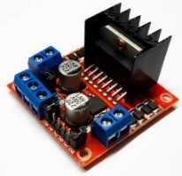

1. **L298N Motor Driver:** L298N Motor Driver used in pen plotter project dual H-bridge module controlling motor speed and direction, enabling precise movement and positioning of the pen in the plotter.

Figure 3.3 L298N Motor Driver

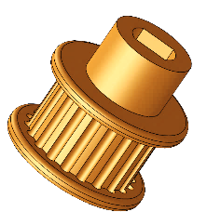

1. **Pulley:** Pulley used in pen plotter project mechanical component with grooves, facilitating smooth and controlled rotation of belts or cables for accurate pen positioning and movement.

Figure 3.4 Pulley

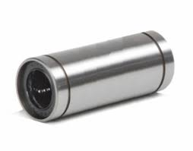

1. **Linear Ball Bearings:** Linear ball bearings used in pen plotter project rolling element bearings providing smooth and low-friction linear motion, ensuring precise and stable movement of the plotter carriage along the rails.

Figure 3.5 Linear Ball Bearing

1. 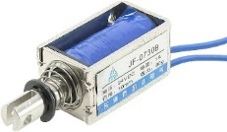**DC Solenoid Electromagnet:** DC solenoid electromagnet used in pen plotter project generates magnetic field when energized, controlling pen up/down movement for precise plotting and drawing on the paper surface.

Figure 3.6 DC Solenoid

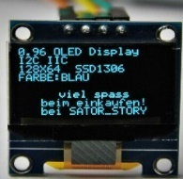

1. **OLED Display:** OLED display used in pen plotter project compact, high-resolution screen for real-time visualization of plotter status, settings, and feedback, enhancing user interface and control.

Figure 3.7 OLED Display

1. 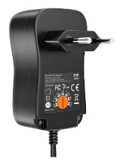**Adapter 12V (DC Power):** 12V DC Adapter used in pen plotter project provides regulated power supply to the plotter system, ensuring stable and reliable operation of the components and motors.

Figure 3.8 Adapter

1. **GT2 Driver Belt:** GT2 driver belt used in pen plotter project high-quality toothed belt for precise and synchronized movement, transferring rotational motion to linear motion with minimal backlash.

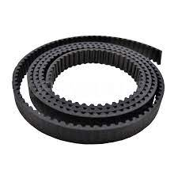

Figure 3.9 GT2 Belt

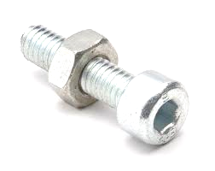

Figure 3.10 Fastener

1. **Screws and Fasteners:** Screws and fasteners used in pen plotter project securely fasten components, ensuring structural integrity and precise alignment for stable and accurate operation of the plotter system.

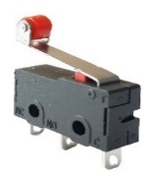

1. **Micro Limit Switch:** Micro Limit Switch used in pen plotter project small, mechanical switch with precise actuation, providing accurate end stop detection for pen movement control and positioning accuracy.

Figure 3.11 Limit Switch

1. 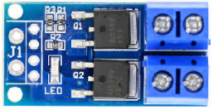 **MOSFET Switch:** MOSFET Switch used in pen plotter project electronic switch with high switching speed and low power dissipation, enabling efficient control of motor and other high-current devices in the plotter system.

Figure 3.12 MOSFET Switch

1. **49E Hall Sensor:** 49E Hall sensor used in pen plotter project magnetic field sensor detecting changes in magnetic field intensity, providing feedback for precise position sensing and control in the plotter system.

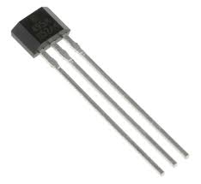

Figure 3.13 Hall Sensor

1. **DC-DC Voltage Converter:** DC-DC voltage converter used in pen plotter project converts input voltage to desired output voltage, providing power flexibility and stability for various components in the plotter system.

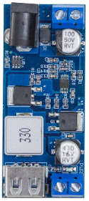

Figure 3.14 DC-DC Voltage Converter

1. **Push Button:** Push button (kill switch) used in pen plotter project emergency stop button for immediate system shutdown, ensuring operator safety and preventing potential accidents during operation.

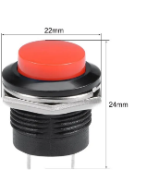

Figure 3.15 Kill Switch

## Electrical Design

Figure 3.16 Electric Circuit Diagram

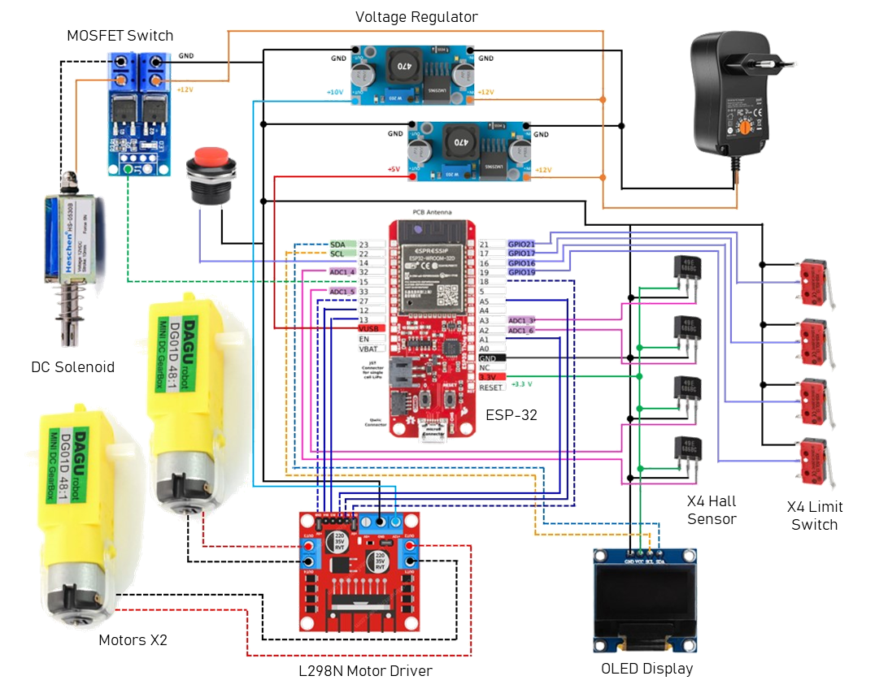

The electrical schematic diagram showcases the circuit configuration of a pen plotter project, demonstrating a well-structured and efficient design. The key components are carefully interconnected to ensure accurate and controlled plotting operations.

The core of the circuit revolves around the ESP32 microcontroller, serving as the main controller controlling X & Y axis motors independently using L298N motor driver. The motor driver allows precise control over the motor speed and direction, enabling smooth and accurate movement of the pen plotter. This configuration ensures that precise drawings can be achieved.

To control the vertical motion of the pen, a 12V DC solenoid with a force of 5N is incorporated. The solenoid acts as a mechanism to raise or lower the pen onto the plotting surface. By selectively activating the solenoid through the microcontroller, the pen can be precisely positioned for drawing or lifted to avoid any unintended marks.

To provide visual feedback and display the operational status of the plotter, a 0.96-inch OLED display is integrated into the circuit. This display offers a clear and concise interface to convey information such as the current progress of a drawing, error messages, or user prompts. It enhances the user experience by providing real-time updates and facilitating interaction with the plotter.

The circuit also incorporates four Hall sensors as encoders to provide precise position feedback. These sensors detect and measure magnetic fields, allowing the microcontroller to accurately determine the pen's position on the plotting surface. This feedback loop ensures precise and reliable plotting, enabling the creation of intricate and well-defined designs.

To establish boundaries in the X-Y plane and prevent any potential damage, limit switches are strategically positioned. These switches act as end stops, halting the movement of the pen plotter when it reaches predefined limits. By triggering the microcontroller upon activation, the limit switches provide an added layer of safety and prevent the plotter from exceeding its designated working area.

In contrast to using a breadboard, the circuit is constructed using a perf-board. This choice eliminates the risk of signal noise caused by loose connections, ensuring a reliable and stable operation of the pen plotter. The perf-board provides a secure and organized platform for assembling the components, contributing to the overall robustness of the system.

In summary, the electrical schematic diagram presents a comprehensive circuit configuration for a pen plotter project. Through the effective integration of the L298 motor driver, ESP32 microcontroller, DC solenoid, OLED display, Hall sensors, limit switches, and perf-board construction, the circuit enables precise control, accurate plotting, and improved reliability, ultimately facilitating the creation of intricate and high-quality drawings.

## Mechanical CAD Design

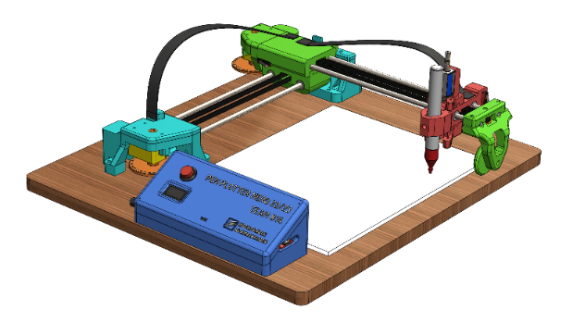

Figure 3.17 CAD Design

As per requirements, the planning phase regarding the design was done and the below procedure was followed:

Initially, the following components were designed accurately by using DSS SolidWorks:

a) Frame and Structure

b) Carriage and Slides

c) Pulley and its fixtures

d) Pen Holder

NOTE: Standard components like DC geared motor, ESP32 microcontroller board, L298N motor driver, 0.96” OLED display, DC solenoid 5N, etc. were downloaded and dimensions were verified with those of physical components.

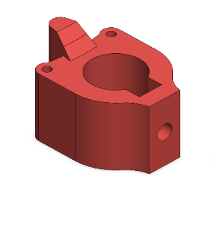

Figure 3.18 Pen Holder

1. **Pen holder:** It is a mechanical component designed to securely hold the pen, enabling controlled and precise movement during plotting. It accommodates different pen sizes, allows for quick pen changes, and ensures consistent pen pressure for accurate and smooth drawings.
2. **Shaft Guiding Block:** It is a sturdy component that supports and guides the shaft, ensuring smooth and precise linear motion of the pen plotter carriage along the rails. It reduces friction, minimizes vibrations, and enhances the overall stability of the system for accurate plotting.

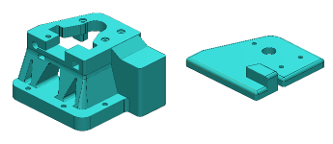

Figure 3.19 Shaft Guiding Block

1. 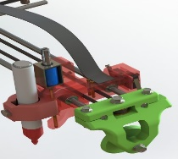**Wheel supporting assembly:** The wheel supporting assembly in a pen plotter project is a crucial component that provides support to the cantilever X-axis. It consists of a rotating wheel mechanism that helps guide the movement of the pen plotter along the X-axis rail. The assembly ensures smooth and stable motion, reducing friction and vibrations for precise plotting and drawing.

Figure 3.20 Wheel supporting assembly

1. **Base Plate:** The base plate in a pen plotter project serves as the foundational chassis on which the entire assembly is mounted. Typically made of wood, it provides stability and support to the various components, ensuring a rigid structure for accurate and reliable pen plotting operations.
2. 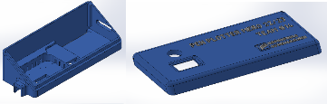**Control Interface Block:** The control interface block in a pen plotter project is a specially designed 3D printed block that serves as a housing for electrical wirings, buttons, and the controller chip. It provides a convenient and organized arrangement, securing and protecting these components, simplifying the wiring connections, and facilitating easy access for control and operation of the pen plotter system.

Figure 3.21 Control Interface Block

## Key Design Decision

Decisions related to design play a crucial role in shaping the user experience of the Pen Plotter. Choosing the right components, materials, and mechanisms ensures that the Pen Plotter performs its intended tasks effectively and efficiently. By making user-centric design decisions, the Pen plotter can be more user-friendly, aesthetically pleasing and enjoyable to operate. Following are the optimal design choices made by our team.

**Position of limit switch for better wiring:** The fixtures were made considering the wiring network of Limit switches, preventing localized wire dispersal and unsightly visibility.

**Use of Display Screen:**  We have used 0.96inch OLED display to following features:

* Welcome Screen
* Web server initialization & local IP
* Home Screen with XY Position & Status of Pen plotter:   
  Jogging/ Calibrating/ Idle/ Plotting
* Warning Screen: Displays the status of all limit switches
* E-Stop active screen with instructions.

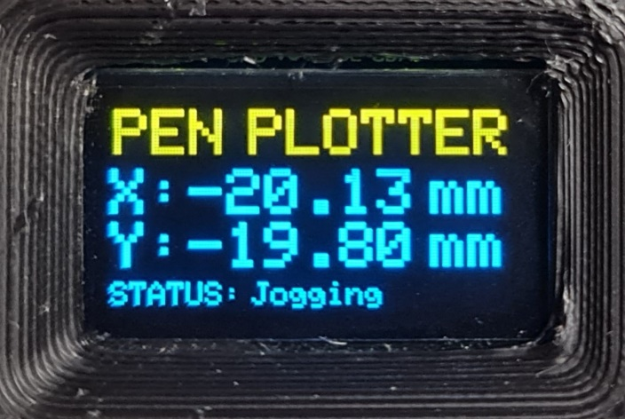

Figure 3.22 OLED Display

**Design of magnetic encoder disc:**

In a pen plotter project, a magnetic encoder system is implemented to convert the rotational motion of DC geared motors into precise linear movements in the XY plane. Hall sensors detect changes in the magnetic field, providing feedback for accurate position sensing, enabling precise pen plotting and drawing on the paper surface.

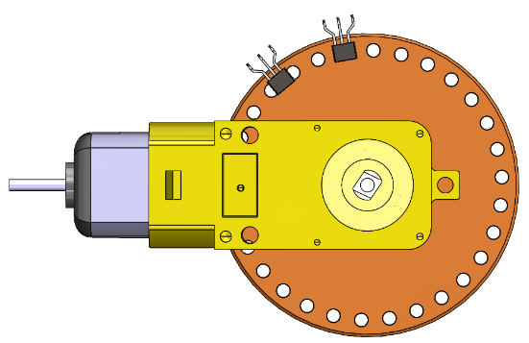

Figure 3.23 Magnetic Encoder Disc

**Enclosure for Electronic circuitry:**

In the pen plotter project, an enclosure is created to conceal the wiring network and electronic circuit components. The enclosure features an OLED display for real-time visualization, an Emergency Stop button for immediate system shutdown, and an ON/OFF switch for easy power control. This housing ensures a clean and organized appearance while providing convenient access to essential controls.

**Graphical User Interface and its features:** Using HTML code, we have designed a web user interface which has the following features:

* Control the movements of pen carriage in XY plane
* Placing the carriage in the drawing area at the specified X, Y coordinates as well as the home location (X=0, Y=0).
* Decision making regarding House width, start position (Point 1 or point 2 of the Nikolaus Haus).
* Raising or lowering the pen against the drawing surface.
* The status of specific Limit Switches changes to “ “when the X or Y carriage slides at the extreme boundaries of the XY plane, and the Webpage blinks yellow.
* Either click the "Emergency button" on the webpage or hold down the "red button" on the Circuitry enclosure for 2 seconds to entirely stop the plotter's activity. This results in a red-blinking website.

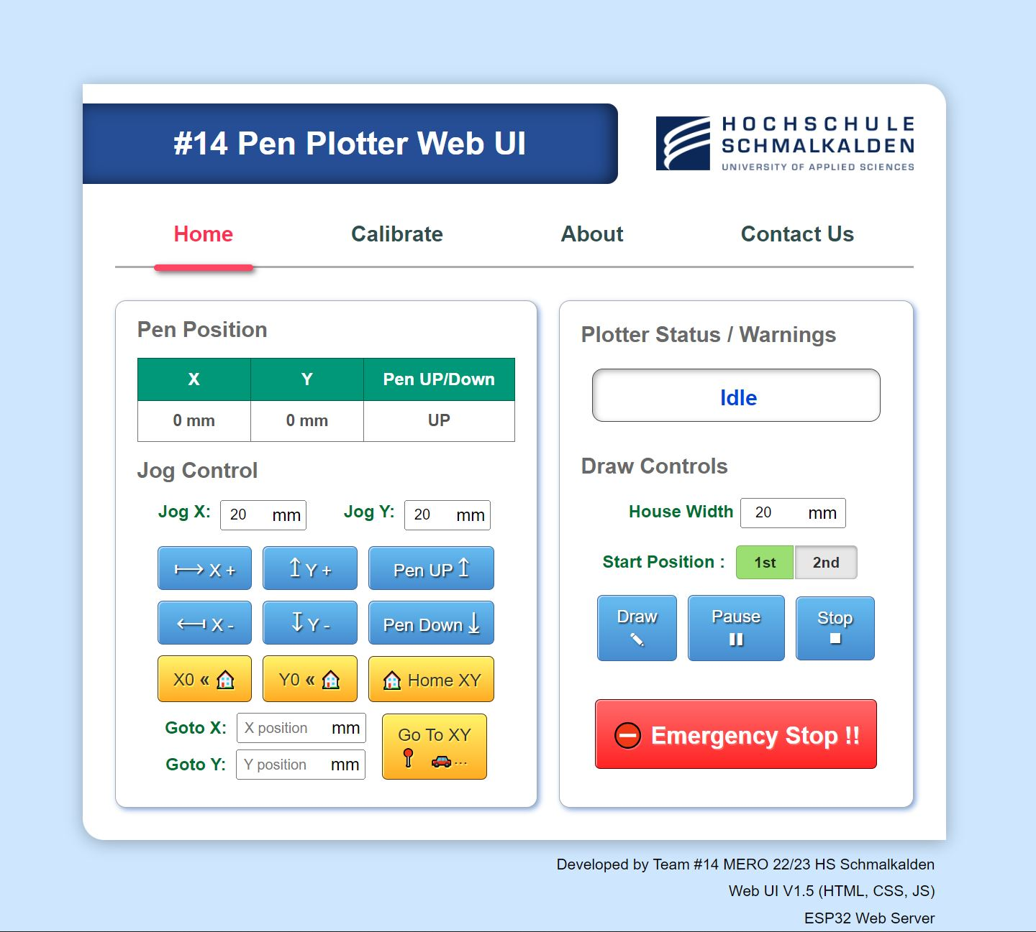

Figure 3.24 Pen Plotter Web UI

# Development and Fabrication Stage

**Process used to develop the pen plotter:** The development and fabrication stage of the pen plotter involves transforming the initial concept into a fully functional device. This includes designing the mechanical structure, selecting and integrating components, fabricating and assembling the physical components, testing the system for functionality and accuracy, and documenting the process for future reference and improvement.

**Selection of materials:** In the common FDM printing process, PLA (Polylactic Acid) is the perfect entry-level filament and can be easily processed by any standard 3D printer. PLA has been chosen for due to:

* Good printability
* Lower distortion (warping) during printing.
* Ease of use
* Affordability, and
* Compatibility with 3D printing technology
* Eco-friendliness
* All the 3D designed components were printed in “QIDI TECH X-MAX 3D Printer” available in the AKT lab, Haus D

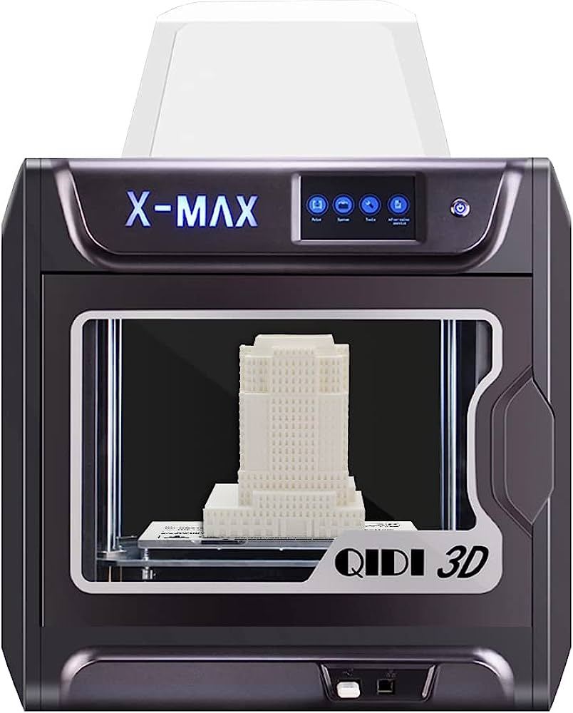

Figure 4.1 3D Printer

**Use of Test Piece:** The use of a test piece in 3D printing allows for evaluating print quality, identifying potential issues, and optimizing printing parameters for correct tolerance and fitment before producing the final parts. It helps ensure accuracy, functionality, and compatibility, minimizing errors and reducing material and time wastage.

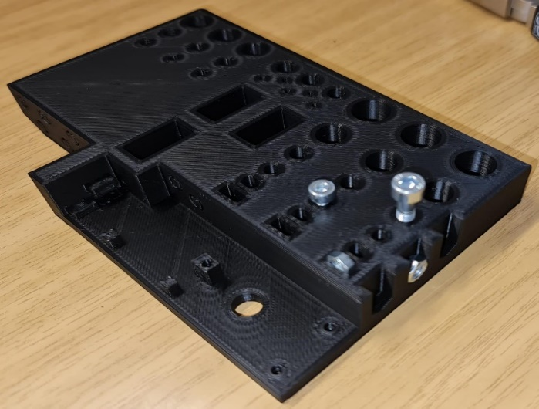

Figure 4.2 Test piece

**Challenges faced during Development Stage:**

**Wires:** Pen plotters deliver precise designs of Nikolaus Haus.

It can generate geometric patterns, and intricate layouts.

Drawings on paper offer a distinct and prominent artistic experience.

Pen plotter has offered the individuals- the potential to brush up on mechanics, electronic components, coding, and applying it.

Plotters provide the ability to draw all the possible patterns and precise movement via user friendly web page.

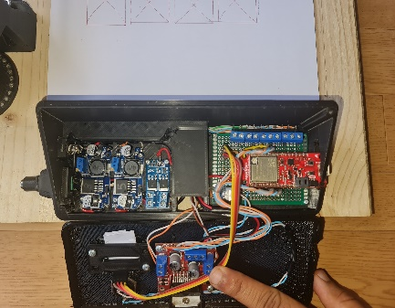

Figure 4.3 Wires and Cables

**Sensors:** Pen plotters deliver precise designs of Nikolaus Haus.

It can generate geometric patterns, and intricate layouts.

Drawings on paper offer a distinct and prominent artistic experience.

Pen plotter has offered the individuals- the potential to brush up on mechanics, electronic components, coding, and applying it.

Plotters provide the ability to draw all the possible patterns and precise movement via user friendly web page.

# Testing and Iteration

The testing and iteration stage in building a pen plotter project involves thoroughly evaluating the system's functionality, performance, and reliability. This includes testing motion control, pen actuation, and plotter coordination, identifying any issues or limitations, and making iterative refinements to optimize the project's overall performance and accuracy.

## Testing Procedure:

* **Limited Color Range**:

Pen plotters typically utilize one color of pen or marker, which limits the usage of color in the artwork to monochrome or a small range of colors. With just pen plotters, it might be difficult to create color combinations that are lively and varied.

* **Slow Speed**:

In comparison to other printing technologies, pen plotters work at comparatively slower speeds. Their effectiveness for large-scale or time-sensitive tasks is constrained by the mechanical nature of the device and the accuracy needed for accurate charting, which can lead to lengthier processing and plotting periods.

* **Positional accuracy**:

Pen plotters may work with DC geared motor as well as Stepper motor. However, with micro-stepping, stepper motors offer superior positional accuracy over dc geared motors.

* **Limited Media Compatibility**:

Pencil plotters function best on flat materials like paper or cardstock. When attempting to plot on unusual or uneven terrain, they could run into problems. The limited media compatibility might prevent experimentation with and examination of various artistic mediums.

## Design Iteration:

The CAD design of the pen plotter project incorporates carefully designed cable routing paths to ensure efficient cable management and minimize potential cable entanglement or obstruction during operation. The aim is to maintain a clean and organized layout while facilitating smooth movement of the plotter. By strategically planning cable routes, potential issues such as cable interference with moving parts, signal interference, and overall system reliability are addressed. Attention is given to factors like cable length, flexibility, and secure attachment points to ensure optimal performance and minimize the risk of cable-related malfunctions. The design considerations emphasize the importance of cable management to maintain a streamlined and efficient operation of the pen plotter.

Table 5.1 Verification Protocol

|  |  |  |  |  |  |
| --- | --- | --- | --- | --- | --- |
| **Verification Protocol** | | | | | |
| **VerP #** | **ref to TS #** | **test procedure (description of routine)** | **verification criterion** | **ref. # (i.e. test protocol, etc)** | **Domain (HW/SW/ME/ALL)** |
| **Application** | | | | | |
| VerP1 | TS2 | Setup pen plotter on a stable surface. Then draw Nikolaus house 40 times. | 40 Nikolaus house drawn | Team14 Doc# 004- MERO_XY_Pen_plotter_Verification.pdf | ALL |
| **General Functions** | | | | | |
| VerP2 | TS5 | Put the pen plotter into a box of 56x39x42 cm provided by Uni Lab. | Fits in box with lid closed | Team14 Doc# 004- MERO_XY_Pen_plotter_Verification.pdf | HW |
| VerP3 | TS9 | Place the pen plotter assembly on a measuring scale with an accuracy of ± 1gm. Take 3 readings and find out their mean value. | Mean of three weight measurement is well below 3500gm | Team14 Doc# 004- MERO_XY_Pen_plotter_Verification.pdf | HW |
| VerP4 | TS11 | Run the Pen Plotter continuously across the paper for 30 min. | Continuous drawing upto 30 min at a time. | Team14 Doc# 004- MERO_XY_Pen_plotter_Verification.pdf | ALL |
| VerP5 | TS12 | Start stopwatch, activate plotter with button, run stopwatch concurrently. Stop timer after drawing completion. Take 3 readings and find out there mean value. | Average Time taken <50 seconds | Team14 Doc# 004- MERO_XY_Pen_plotter_Verification.pdf | ALL |
| VerP6 | TS12 | Move the Pen from point A (0,0) to Point B (100,100) 20 times and measure the error at Point B for each cycle . | Average error <= ± 0.25mm | Team14 Doc# 004- MERO_XY_Pen_plotter_Verification.pdf | ALL |
| VerP7 | TS14 | Start the pen plotter and take noise level measurement by sound level meter. Take 5 readings and find out their mean value. | Mean of three noise measurement is <=60 dBA | Team14 Doc# 004- MERO_XY_Pen_plotter_Verification.pdf | HW/ME |
| **Module Motor Controller Electronics and Wiring** | | | | | |
| VerP8 | TS30 | Confirm switch functionality, halt plotter movement when contacted by levers, preventing overtravel and ensuring accurate and safe plotting. Check 10 times. | Overtravel prevention, accurate and safe plotting. | Team14 Doc# 004- MERO_XY_Pen_plotter_Verification.pdf | HW |
| **Module Base Plate** | | | | | |
| VerP9 | TS36 | Align the plotter for accurate plotting within the maximum A4 size. Perform 10 test plot using an A4-sized drawing media. | Maximum size of drawing media = A4. | Team14 Doc# 004- MERO_XY_Pen_plotter_Verification.pdf | HW |
| **Module Pen Holder / Carriage** | | | | | |
| VerP10 | TS45 | Gather pens, position them and measure the diameter by Vernier caliper. Record the measurement results for each pen. | The diameter is less than 15mm | Team14 Doc# 004- MERO_XY_Pen_plotter_Verification.pdf | ME |
| VerP11 | TS47 | Drawing media is positioned correctly, and maximum thickness of drawing media(wood base,etc) 3cm. | Maximum thickness of drawing media = 3cm. | Team14 Doc# 004- MERO_XY_Pen_plotter_Verification.pdf | HW/ME |
| **Module Coding, Control & User Interface** | | | | | |
| VerP12 | TS53 | Power on, calibrate for accuracy (repeat 5 times), test emergency stop. Establish reliable starting point, align X and Y axis, move to specific point & check error. | Calibration (5 times), X and Y alignment, move to point, check error and usage of emergency stop. | Team14 Doc# 004- MERO_XY_Pen_plotter_Verification.pdf | SW |
| VerP13 | TS54 | Check the OLED/LCD Display for real-time display of status of the machine. | Displays the real-time of operations ongoing for the XY Pen plotter. | Team14 Doc# 004- MERO_XY_Pen_plotter_Verification.pdf | SW/HW |

Table 5.2 Verification Report

|  |  |  |  |  |  |  |  |  |
| --- | --- | --- | --- | --- | --- | --- | --- | --- |
| **Verification Report** | | | | | | | | |
| **VerR #** | **ref. to VerP #** | **Test function (to be copied from verification protocol)** | **verification criterion, the target value** | **actual value** | **criterion passed/failed** | **remark** | **ref. # (i.e. test report, etc)** | **Domain (HW/SW/ME/ALL)** |
| **Application** | | | | | | | | |
| VerR1 | VerP1 | To draw Nikolaus haus until failure or more than 40 times. | 40 drawings without error | All the 40 houses are drawn correctly. | Passed |  | Team14 Doc# 004- MERO_XY_Pen_plotter_Verification.pdf | ALL |
| **General Functions** | | | | | | | | |
| VerR2 | VerP2 | To put the pen plotter into a box of 56x39x42 cm^3 provided by Uni Lab. | Fits in box with lid closed | Fits perfectly | Passed |  | Team14 Doc# 004- MERO_XY_Pen_plotter_Verification.pdf | HW |
| VerR3 | VerP3 | To ensure that pen plotter assembly weighs less than 3.5 kgs. | Weight <= 3.5kg | 2.8kg | Passed |  | Team14 Doc# 004- MERO_XY_Pen_plotter_Verification.pdf | HW |
| VerR4 | VerP4 | Ensuring continuous run time of Pen Plotter across the paper for 30 min. | Continuous drawing upto 30 min at a time. | 30 min | Passed |  | Team14 Doc# 004- MERO_XY_Pen_plotter_Verification.pdf | ALL |
| VerR5 | VerP5 | Drawing time to be maintained less than 50s. | Time taken< 50 seconds. | 45 seconds | Passed |  | Team14 Doc# 004- MERO_XY_Pen_plotter_Verification.pdf | ALL |
| VerR6 | VerP6 | Check the average error in movement across Point A to Point B after 20 cycles of operation. | Average error <= ± 0.25mm | Error <= ± 0.25mm | Passed |  | Team14 Doc# 004- MERO_XY_Pen_plotter_Verification.pdf |  |
| VerR7 | VerP7 | Start the pen plotter and take noise level measurement to find out their mean value. | Noise level should be less than 60 dBA | 55dB | Passed |  | Team14 Doc# 004- MERO_XY_Pen_plotter_Verification.pdf | HW/ME |
| **Module Motor Controller Electronics and Wiring** | | | | | | | | |
| VerR8 | VerP8 | Confirm switch functionality, halt plotter movement when contacted by levers, preventing overtravel and ensuring accurate and safe plotting. check 10 times. | Accurate functionality and safe plotting | All the switches work properly. | Passed |  | Team14 Doc# 004- MERO_XY_Pen_plotter_Verification.pdf | HW |
| Module Base Plate |  |  |  |  |  |  |  |  |
| VerR9 | VerP9 | Align the plotter for accurate plotting within the maximum A4 size. Perform 10 test plot using an A4-sized drawing media. | Drawing media size = A4. | A4 | Passed |  | Team14 Doc# 004- MERO_XY_Pen_plotter_Verification.pdf | HW |
| **Module Pen Holder / Carriage** | | | | | | | | |
| VerR10 | VerP10 | Maximum pen diameter used is less than or equal to 15mm | Diameter <=15mm | 13mm | Passed |  | Team14 Doc# 004- MERO_XY_Pen_plotter_Verification.pdf | ME |
| VerR11 | VerP11 | Determine the max. Permissible Drawing media thickness | Maximum thickness of drawing media >= 5mm. | 3cm | Passed |  | Team14 Doc# 004- MERO_XY_Pen_plotter_Verification.pdf | HW/ME |
| **Module Coding, Control & User Interface** | | | | | | | | |
| VerR12 | VerP12 | Start, Calibrate (5x), Test Emergency Stop. Establish starting point, Align X and Y, Move to point, Check error. | Execute all the given tasks/functions. | All the functions were working properly. | Passed |  | Team14 Doc# 004- MERO_XY_Pen_plotter_Verification.pdf | SW |
| VerR13 | VerP13 | Check the real-time display of status of the machine for monitoring. | Ensure the display updates real-time status and working of emergency stop status, with clear visibility for effective monitoring. | Display shows the detailed status on OLED/LCD Display. | Passed |  | Team14 Doc# 004- MERO_XY_Pen_plotter_Verification.pdf | HW |

Table 5.3 Validation Protocol

|  |  |  |  |  |
| --- | --- | --- | --- | --- |
| **Validation Protocol** | | | | |
| **ValP #** | **ref. to UR #** | **Validation procedure( description of routine)** | **ref. # (i.e.  validation  protocol, customer test, etc..)** | **validation criterion, target value** |
| ValP1 | UR1, UR2, UR3, UR4 | Set-up pen plotter at the university's lab, start pen plotter by student, draw Nikolaus haus. | Team14 Doc# 005- MERO_XY_Pen_plotter_Validation.pdf | Plotter must draw Nikolaus house in one run. |
| ValP2 | UR5 | Put the pen plotter into a box of 56x39x42 cm provided by Uni Lab. | Team14 Doc# 005- MERO_XY_Pen_plotter_Validation.pdf | Fits perfectly |
| ValP3 | UR7 | Place the pen plotter assembly on a measuring scale with an accuracy of ± 1gm | Team14 Doc# 005- MERO_XY_Pen_plotter_Validation.pdf | Total weight <= 3.5kg |
| ValP4 | UR9 | Continuous drawing upto 30 min at a time. | Team14 Doc# 005- MERO_XY_Pen_plotter_Validation.pdf | 30 min. |
| ValP5 | UR10 | Compare the calculated mean value with expected results or specifications to ensure the accuracy of the timing measurements. | Team14 Doc# 005- MERO_XY_Pen_plotter_Validation.pdf | Average error <= ± 0.25mm |
| ValP 6 | UR11 | Start the pen plotter and take noise level measurement by sound level meter. | Team14 Doc# 005- MERO_XY_Pen_plotter_Validation.pdf | Average noise measure <=60 dBA |
| ValP 7 | UR27 | Verify switch functionality by testing 10 times, ensuring successful halting of plotter movement upon contact with levers, preventing overtravel and ensuring accurate and safe plotting. | Team14 Doc# 005- MERO_XY_Pen_plotter_Validation.pdf | All the switches work properly. |
| ValP 8 | UR41 | Maximum pen diameter of 15mm | Team14 Doc# 005- MERO_XY_Pen_plotter_Validation.pdf | Pen diameter <=15mm |
| ValP 9 | UR45 | Maximum thickness of drawing media = 3cm. | Team14 Doc# 005- MERO_XY_Pen_plotter_Validation.pdf | Maximum thickness of drawing media >= 5mm. |
| ValP 10 | UR50 | Perform a series of tests including starting, calibrating (5 times), testing emergency stop, establishing starting point, aligning X and Y axis, moving to a specific point, and checking for any errors. | Team14 Doc# 005- MERO_XY_Pen_plotter_Validation.pdf | All the functions are working properly. |
| ValP 11 | UR52 | Verify the display by confirming real-time distance lag updates, accurate emergency stop status representation, and clear visibility for effective monitoring. | Team14 Doc# 005- MERO_XY_Pen_plotter_Validation.pdf | Display shows the detailed status on OLED/LCD Display. |

Table 5.4 Validation Report

|  |  |  |  |
| --- | --- | --- | --- |
| **Validation Report** | | | |
| **ValR #** | **ref. to ValP #** | **criteria (passed/failed)** | **ref. # (i.e. test report, etc..)** |
| ValR1 | ValP1 | Passed | Team14 Doc# 005- MERO_XY_Pen_plotter_Validation.pdf |
| ValR2 | ValP2 | Passed | Team14 Doc# 005- MERO_XY_Pen_plotter_Validation.pdf |
| ValR3 | ValP3 | Passed | Team14 Doc# 005- MERO_XY_Pen_plotter_Validation.pdf |
| ValR4 | ValP4 | Passed | Team14 Doc# 005- MERO_XY_Pen_plotter_Validation.pdf |
| ValR5 | ValP5 | Passed | Team14 Doc# 005- MERO_XY_Pen_plotter_Validation.pdf |
| ValR6 | ValP 6 | Passed | Team14 Doc# 005- MERO_XY_Pen_plotter_Validation.pdf |
| ValR7 | ValP 7 | Passed | Team14 Doc# 005- MERO_XY_Pen_plotter_Validation.pdf |
| ValR9 | ValP9 | Passed | Team14 Doc# 005- MERO_XY_Pen_plotter_Validation.pdf |
| ValR10 | ValP10 | Passed | Team14 Doc# 005- MERO_XY_Pen_plotter_Validation.pdf |
| ValR11 | ValP11 | Passed | Team14 Doc# 005- MERO_XY_Pen_plotter_Validation.pdf |
| ValR12 | ValP12 | Passed | Team14 Doc# 005- MERO_XY_Pen_plotter_Validation.pdf |

# Conclusion and Acknowledgements

In conclusion, our pen plotter project has successfully come to fruition, showcasing the seamless integration of a diverse range of components. The project has been a testament to our team's dedication, expertise, and collaborative effort. The utilization of key components such as DC motors, an ESP32 board for efficient control, a DC-DC converter for optimized power management, a Hall sensor and encoder for precise positioning, a linear ball bearing for smooth pen movement, pulleys for accurate belt drive, a DC solenoid for pen lifting, an OLED display for intuitive user interaction, and micro limit switches for reliable end stop detection has resulted in a high-performing and user-friendly pen plotter.

We extend our heartfelt gratitude to all those who have contributed to the success of this project. Our appreciation goes to the team members who worked diligently on every aspect, from design to implementation, ensuring the functionality and performance of the pen plotter. We would also like to acknowledge the support and guidance provided by our mentors and advisors, whose expertise has been invaluable throughout the project's development.

The successful completion of this pen plotter project opens up new possibilities in creative expression and design, and we look forward to further refining and expanding its capabilities in the future.

## Bill of Materials:

Table 6.1 Bill of Material

|  |  |  |  |  |  |  |  |
| --- | --- | --- | --- | --- | --- | --- | --- |
| Item | Description | Material | Source | Qyt. | Measurement | Unit Price(euro) | Total Price(euro) |
| Mechanical Components | |  |  |  |  |  |  |
| M01 | Guiding Shaft |  | University Lab | 4 |  | 3 | 12 |
| M02 | Timing Belt |  | University Lab | 1 | 1.2 meter | 2.06 | 2.06 |
|  |  |  |  |  |  | **Subtotal** | **14.06** |
| Electrical Components |  |  |  |  |  |  |  |
| E01 | ESP32 Board |  | University Lab | 1 |  | 3.2 | 3.2 |
| E02 | Motor Driver |  | University Lab | 1 |  | 18.99 | 18.99 |
| E03 | Power Module |  | University Lab |  |  | 5.45 | 5.45 |
| E04 | DC Motor |  | University Lab | 2 |  | 7.25 | 14.5 |
| E05 | Limit Switch |  | University Lab | 4 |  | 1 | 4 |
| E06 | Bread Board and Jumper Cables |  | University Lab |  |  |  | 5 |
| E07 | Linear Ball Bearing |  | University Lab | 6 |  | 2 | 12 |
| E08 | DC Solenoid Electromagnet |  |  | 1 |  | 6.19 | 6.19 |
| E09 | OLED Display |  |  | 1 |  | 5.5 | 5.5 |
| E10 | Adaptor 12V (DC Power) |  |  | 1 |  | 16.91 | 16.91 |
| E11 | Micro Limit Switch |  | University Lab | 4 |  | 0.65 | 2.6 |
| E12 | MOSFET Switch |  |  | 1 |  | 6.95 | 6.95 |
| E13 | 49E Hall Sensor |  | University Lab | 4 |  | 3 | 12 |
| E14 | DC-DC Voltage Convertor |  |  | 1 |  | 6.89 | 6.89 |
| E15 | Ethernet Cable |  |  | 1 |  | 3 | 3 |
|  |  |  |  |  |  | **Subtotal** | 123.18 |
| 3D Printed Components |  |  |  |  |  |  |  |
| P01 | Encoder Wheel | PLA filament | University Lab | 2 |  |  |  |
| P02 | GT2 20T Pulley | PLA filament | University Lab | 4 |  |  |  |
| P03 | GT2 20T Pulley End Cap | PLA filament | University Lab | 8 |  |  |  |
| P04 | X Axis Motor Fixture | PLA filament | University Lab | 1 |  |  |  |
| P05 | X Carriage | PLA filament | University Lab | 4 |  |  |  |
| P06 | Y Axis Motor Fixture | PLA filament | University Lab | 1 |  |  |  |
| P07 | Y Axis Motor Fixture Cap | PLA filament | University Lab | 1 |  |  |  |
| P08 | Y Axis Pulley fixture | PLA filament | University Lab | 1 |  |  |  |
| P09 | Y Axis Pulley Fixture Cover | PLA filament | University Lab | 1 |  |  |  |
| P10 | Y Carriage | PLA filament | University Lab | 5 |  |  |  |
| P11 | Base Board Cover | PLA filament | University Lab | 3 |  |  |  |
| P12 | GT2 15T motor pulley | PLA filament | University Lab | 2 |  |  |  |
| P13 | GT2 15T motor pulley top | PLA filament | University Lab | 1 |  |  |  |
| P14 | Y Axis Fixture | PLA filament | University Lab | 1 |  |  |  |
| P15 | X Axis Roller | PLA filament | University Lab | 1 |  |  |  |
|  |  |  |  |  |  | **Subtotal** |  |

## Future Scope:

Pen plotters have a bright future with lots of room for innovation and growth. In order to create immersive and interactive artistic experiences: Use of higher-quality DC geared motors with finer gear ratios to achieve more accurate positioning and smoother movement. Working on the design and making it more reliable and efficient so that the vibrations can be reduced and quality of the drawing can be improved. Future designs might focus on reducing the size and weight of the plotter while maintaining its functionality and performance.

In addition to the points mentioned above, the future of pen plotters holds several possibilities for innovation and growth:

* Integration of AI and Machine Learning: By integrating artificial intelligence (AI) and machine learning algorithms, pen plotters can gain the ability to analyse and reproduce complex artistic styles or patterns. This would enable the creation of unique and customized drawings based on user preferences or learned artistic techniques.
* Multi-Color and Mixed-media Capabilities: Expanding the capabilities of pen plotters to accommodate multiple colours or even different drawing mediums (such as pencils or markers) can open up new avenues for creativity and artistic expression.
* Collaborative Features: Developing collaborative features, allowing multiple pen plotters to work together on a single drawing or synchronized artwork, could facilitate group projects, interactive installations, or even live art performances.

Overall, the future of pen plotters is bright, with the potential for advancements in accuracy, connectivity, control systems, AI integration, and collaborative capabilities, promising immersive and interactive artistic experiences for users.